CYSC Meeting Minutes
4.27.2021
Members present via Zoom conference: Eric Gervase, Andrea Loud, Caramie Oberholtzer, Shaun Kaley, Josh Nichols, Tony Nicolodi, Russ Hohl, Jodi Ho, Roger Weir, Rachel Wenger

*Follow-up Action Items

U6 – Caramie Oberholtzer
- Things going fairly well.
- One complaint about too many kids on the field, playing 4 v 4. Kids just storm the ball.
- *Caramie and Rachel to meet for uniform money exchange.

U8 – Jodi Ho
- Going well, no known issues
- Josh suggested Goal kick rules in the future.
- OK to have teams that were “down” due to COVID still practice on nights of select tryout.
- Rachel has money from uniforms and one registration

Secretary – Jodi Ho
- Signs ordered and paid for by Rachel
- Saving and tracking COVID

Coach Updates– Josh
- No updates

Equipment – Eric
- Eric ordered a few sets of nets

- Roger put more coaching bags together, around $2,000 in equipment from Sneaker Villa. Balls, Pinnies.

LARS - Eric
- Trying to reinforce mask

RBJSL - Eric
- Similar LARS Mask update
- Were flexible with roosters and allowed us to bring a player up to keep game going

COVID Update - Eric
- 2 U8 teams were down
- Total of 4 rec and travel teams down
- Some players out. Slowing down now.

Registrar – Shaun
- Seasonal registration done.
- Will prepare for LARS

Select tryouts – Annie
- Annie, Toni and Josh to coordinate
- More small-sided games vs. drills
- Select Tryout Dates
5/11, 5/12, 5/17, 5/18 – no practices during tryouts

STAR Soccer camp June 13th camp

Scholarship update – Rachel
- Applications in. Rachel will forward for review to board.
- *Continue what we did in the past. $250/$500 1 each for boys and girls. Reach out to booster clubs to see how to coordinate.

LARS committed – Eric, Travis Schumacher, Ephrata’s President as guest
- June 5th and 6th; Saturday 8:00 a.m.-6:00 p.m., Sunday 12:00-6:00 p.m.
- Paid roles
  - *Schedule referees - this is probably the toughest task – Craig felt good pool
  - *Schedule Field Marshalls - we can probably sub out this task to individual clubs hosting. But, we'd still need to find our own for our fields.
  - *Get parking attendants on site
- Registration and game scheduling
  - *Create registration pages on website for teams to apply
  - *Create preliminary game schedules for each age group for planning
  - *Create final schedule once teams register
- Recommendation is to forego food sales this season so that we don't have people gathering in one place and instruct teams to stay together on their own. With 1/3 of the teams on location, it should make it way more manageable.
- Cocalico and Ephrata, possibly Garden Spot too
- Only con is need more people when spreading it out.
- Ephrata would be entered for free – 5 teams
- *Trophies – Need someone to Coordinate
- Below is a short "fact sheet" of preliminary info given all the teams opt in. We usually have about 90% of the teams play. That may be less this year as we have put out a "only come if you intend to follow mask rules" kind of email to the league. But, we'll find out more as we open registration.

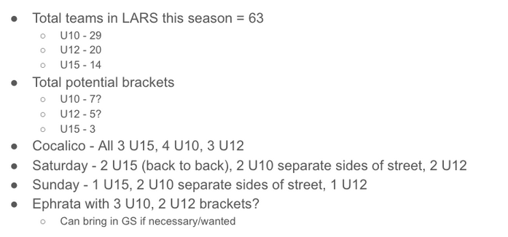

Treasurer – Rachel Wenger/ Christina Pehote
- Current Account Balances:
  - Operating: $
  - LARS: $
  - Total:

